Preparation of Papers for the International Conference on Environmental Systems
First A. Author and Second B. Author, Jr.
Business or Academic Affiliation 1, City, State, Zip Code
Third Author
Business or Academic Affiliation 2, City, Province, Zip Code, Country
and
Fourth C. Author
Business or Academic Affiliation 2, City, State, Zip Code
These instructions give you guidelines for preparing papers for the International Conference on Environmental Systems. Use this document as a template if you are using Microsoft Word 2000-XP or later, or Word for Mac. Otherwise, use this document as an instruction set. Define all symbols used in the abstract. Do not cite references in the abstract. The footnote on the first page should list the Job Title and other contact information for each author.

Nomenclature
A = amplitude of oscillation
a = cylinder diameter
C_{p} = pressure coefficient
Cx = force coefficient in the x direction
Cy = force coefficient in the y direction
c = chord
dt = time step
Fx = X component of the resultant pressure force acting on the vehicle
Fy = Y component of the resultant pressure force acting on the vehicle
f, g = generic functions
h = height
i = time index during navigation
j = waypoint index
K = trailing-edge (TE) nondimensional angular deflection rate

Introduction
T
HIS document is a template for Microsoft Word version 2000-XP, Microsoft Word version 2003, or Word for Mac OS X. If you are reading a hardcopy or PDF version of this document, please download the electronic template file from the conference web site at https://www.ices.space.
To create your formatted manuscript, type your own text over the appropriate sections of this document, or cut and paste from another document and then use the available markup styles. Highlight a section that you want to designate with a certain style, then select the appropriate style name from the style menu. The style will automatically adjust your fonts and line spacing. Do not change the font sizes, line spacing, or margins. Use italics for emphasis; do not underline.

Procedure for Paper Submission
All manuscripts are to be submitted electronically to the EasyChair site created for the conference. Final manuscripts must be saved in a searchable pdf format before submitting. Submission instructions are available on the conference web site.

Paper Review Considerations
It is the responsibility of the author to obtain any required government or company reviews for their papers in advance of publication. Start early to determine if the reviews are required; this process can take several weeks.

Detailed Formatting Instructions
The styles and formats for the ICES paper template have been incorporated into the structure of this document. If you are using Microsoft Word 2000 or later, please use this template to prepare your manuscript. If you are reading a hardcopy or PDF version of this document, please download the electronic template file from the conference web site at https://www.ices.space. Regardless of which program you use to prepare your manuscript, please use the formatting instructions contained in this document as a guide.
If you are using the electronic version of this template to prepare your manuscript, you can simply type your own text over sections of this document, or cut and paste from another document and use the available markup styles. The Microsoft Word document contains all the styles you will need to format your document. Highlight a section that you want to designate with a certain style and then select the appropriate style name from the style menu. The style will automatically adjust your fonts, tabs, and line spacing as appropriate. Do not change the font sizes, line spacing, or margins. Use italics for emphasis; do not underline. Be sure to replace “Paper Number” in the header on the first page with the actual paper number. Use the “Print Layout” Document View to see the most accurate representation of how your final paper will appear.

Page Limit
The recommended length for the paper is 8 to 10 pages. There is a maximum page limit of 15 pages.

Document Text
The default font for ICES papers is Times New Roman, 10-point size. In the electronic template, use the “Text” style to format all primary text for your manuscript. The first line of every paragraph should be indented, and all lines should be single-spaced. Default margins are 1” on all sides. In the electronic version of this template, all margins and other formatting is preset. There should be no additional lines between paragraphs.
Extended quotes, such as this example, are to be used when material being cited is longer than a few sentences, or the standard quotation format is not practical. In this Word template, the appropriate style is “Extended Quote.” Extended quotes are to be in Times New Roman, 9-point font, indented 0.4” and full justified.
NOTE: If you are using the electronic template to format your manuscript, the required spacing and formatting will be applied automatically, simply by using the appropriate style designation.

Headings
The title of your paper should be typed in bold, 18-point type, with capital and lower-case letters (title capitalization, not all caps), and centered at the top of the page.
Major headings (“Heading 1” in the template style list) are bold 11-point font, centered, and numbered with Roman numerals.
Subheadings (“Heading 2” in the template style list) are bold, flush left, and numbered with capital letters.
Sub-Subheadings (“Heading 3” in the template style list) are italic, flush left, and numbered (1. 2. 3. etc.)

Authors
The names of the authors, business or academic affiliation, city, and state/province should follow on separate lines below the title. The names of authors with the same affiliation can be listed on the same line above their collective affiliation information. Author names are centered, and affiliations are centered and in italic type. The affiliation line for each author is to include that author’s city, state, and zip/postal code (or city, province, zip/postal code and country, as appropriate). The first footnote (lower left-hand side) is to contain the job title and department name, and street address/mail stop for each author.
Each person who had a significant contribution to the work should be included. A person who made only minor contributions, such as reading the paper and giving feedback, should not be included in the list of authors. It may be more appropriate to include this person in the acknowledgments section. Due to space limitations, only the first 8 authors from the submission metadata in EasyChair will be listed in the printed program.

Abstract
The abstract should appear at the beginning of your paper. It should be one paragraph long (not an introduction) and complete in itself (no reference numbers). It should indicate subjects dealt with in the paper and state the objectives of the investigation. Newly observed facts and conclusions of the experiment or argument discussed in the paper must be stated in summary form; readers should not have to read the paper to understand the abstract. The abstract should be bold, indented 1/2” on each side, and separated from the rest of the document by two blank lines.

Copyright
If your organization requires a copyright notice on the paper, it should be included in the footer at the bottom of the first page in the template. If a copyright notice is not required, then delete the footer on the first page. The ICES organization does NOT claim the copyright to the papers. If the author works for the United States Federal Government and the work reported in the paper was performed as part of their employment, the work is considered public information and not copyrighted. For further information, see the Author Instructions on the conference web site.

Footnotes and References
Footnotes, where they appear, should be placed above the 1” margin at the bottom of the page. To insert footnotes into the template, use the Insert>Footnote feature from the main menu as necessary. Footnotes are formatted automatically in the template, but if another medium is used, should appear in superscript as symbols in the sequence, *, †, ‡, §, ¶, #, **. ††, ‡‡, §§, etc.
List and number all bibliographical references at the end of the paper. Corresponding superscript numbers are used to cite references in the text,¹ unless the citation is an integral part of the sentence (e.g., “It is shown in Ref. 2 that…”) or follows a mathematical expression: “A² + B = C (Ref. 3).” For multiple citations, separate reference numbers with commas,^{4,5} or use a dash to show a range.⁶⁻⁸ Reference citations in the text should be in numerical order.
In the reference list, give all authors’ names; do not use “et al.” unless there are six authors or more. Papers that have not been published should be cited as “unpublished”; papers that have been submitted or accepted for publication should be cited as “submitted for publication.” Private communications and personal Web sites should appear as footnotes rather than in the reference list.
References should be cited according to the standard publication reference style (for examples, see the “References” section of this template). As a rule, all words are capitalized except for articles, conjunctions, and prepositions of four letters or fewer. Names and locations of publishers should be listed; month and year should be included for reports and papers. For papers published in translation journals, please give the English citation first, followed by the original foreign language citation.

Images, Figures, and Tables
All artwork, captions, figures, graphs, and tables will be included exactly as submitted. Be sure to position any figures, tables, graphs, or pictures as you want them to appear.
Tables and figures of all types may be inserted into text boxes (or frames, if text boxes are not practical) as illustrated here, or directly in line with the text. Text boxes should have no background and no outlines. Both the illustration itself and the caption should be included in the same box. In the electronic template, use the “Figure” style from the pull-down formatting menu to type caption text. Captions are bold and justified, with a period after the figure number and the figure description.
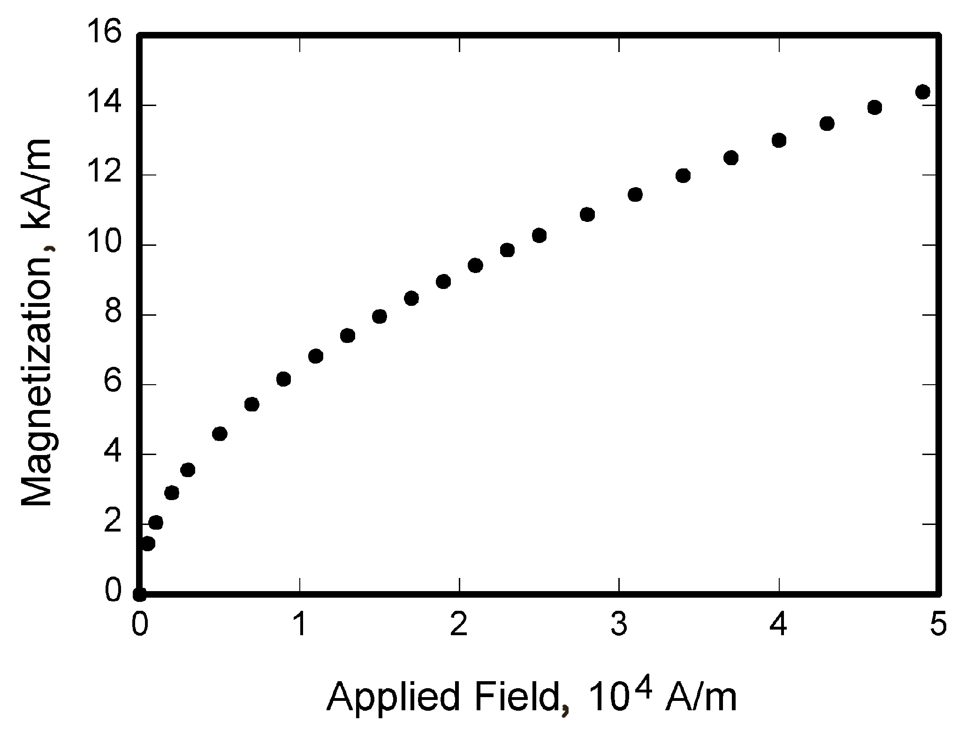
Figure 1. Magnetization as a function of applied field. Figure captions should be bold and justified, with a period and a single tab (no hyphen or other character) between the figure number and the figure description.

Place figure captions below all figures; place table titles above the tables. If your figure has multiple parts, include the labels “a),” “b),” etc. below and to the left of each part, above the figure caption. Please verify that the figures and tables you mention in the text actually exist. Please do not include captions as part of the figures, and do not put captions in separate text boxes linked to the figures. Number each different type of illustration (i.e., figures, tables, images) sequentially with relation to other illustrations of the same type.
Figure axis labels are often a source of confusion. Use words rather than symbols. As in the example to the right, write the quantity “Magnetization” rather than just “M.” Do not enclose units in parenthesis, but rather separate them from the preceding text by commas. Do not label axes only with units. As in Figure 1, for example, write “Magnetization, A/m” or “Magnetization, Am⁻¹,” not just “A/m.” Do not label axes with a ratio of quantities and units. For example, write “Temperature, K,” not “Temperature/K.”
Multipliers can be especially confusing. Write “Magnetization, kA/m” or “Magnetization, 10³ A/m.” Do not write “Magnetization (A/m) x 1000” because the reader would not then know whether the top axis label in Figure 1 meant 16000 A/m or 0.016 A/m. Figure labels must be legible, approximately 8-12 point type.

Units of Measurement
Use SI units of measurement. When English units are given preference, the SI equivalent should be provided in parentheses. When SI units are given preference, English units may be provided in parentheses.

Equations, Numbers, Symbols, and Abbreviations
Equations are centered and numbered consecutively, with equation numbers in parentheses flush right, as in Eq. (1). Insert a blank line on either side of the equation. First use the equation editor to create the equation. If you are using Microsoft Word, use either the Microsoft Equation Editor or the MathType add-on (http://www.mathtype.com) for equations in your paper, use the function (Insert>Object>Create New>Microsoft Equation or MathType Equation) to insert it into the document. Please note that “Float over text” should not be selected. To insert the equation into the document:
          - Select the “Equation” style from the pull-down formatting menu and hit “tab” once.
          - Insert the equation, hit “tab” again,
          - Enter the equation number in parentheses.
A sample equation is included here, formatted using the preceding instructions. To make your equation more compact, you can use the solidus (/), the exp function, or appropriate exponents. Use parentheses to avoid ambiguities in denominators.
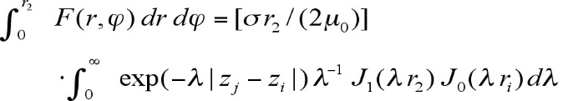 (1)
Be sure that the symbols in your equation are defined before the equation appears, or immediately following. Italicize symbols (T might refer to temperature, but T is the unit tesla).
Define abbreviations and acronyms the first time they are used in the text, even after they have already been defined in the abstract. Very common abbreviations such as AIAA, SI, ac, and dc do not have to be defined. Abbreviations that incorporate periods should not have spaces: write “P.R.,” not “P. R.” Delete periods between initials if the abbreviation has three or more initials; e.g., U.N. but ESA. Do not use abbreviations in the title unless they are unavoidable.

General Grammar and Preferred Usage
Hyphenate complex modifiers: “zero-field-cooled magnetization.” Avoid dangling participles, such as, “Using Eq. (1), the potential was calculated.” [It is not clear who or what used Eq. (1).] Write instead “The potential was calculated using Eq. (1),” or “Using Eq. (1), we calculated the potential.”
Use a zero before decimal points: “0.25,” not “.25.” Use “cm²,” not “cc.” Indicate sample dimensions as “0.1 cm x 0.2 cm,” not “0.1 x 0.2 cm².” The preferred abbreviation for “seconds” is “s,” not “sec.” Do not mix complete spellings and abbreviations of units: use “Wb/m²” or “webers per square meter,” not “webers/m².” When expressing a range of values, write “7 to 9” or “7-9,” not “7~9.”
A parenthetical statement at the end of a sentence is punctuated outside of the closing parenthesis (like this). (A parenthetical sentence is punctuated within parenthesis.) In American English, periods and commas are placed within quotation marks, like “this period.” Other punctuation is “outside”! Avoid contractions; for example, write “do not” instead of “don’t.” The serial comma is preferred: “A, B, and C” instead of “A, B and C.”
If you wish, you may write in the first person singular or plural and use the active voice (“I observed that…” or “We observed that…” instead of “It was observed that…”). Remember to check spelling. If your native language is not English, please ask a native English-speaking colleague to proofread your paper.
The subscript for the permeability of vacuum µ₀ is zero, not a lowercase letter “o.” The term for residual magnetization is “remanence”; the adjective is “remanent”; do not write “remnance” or “remnant.” The word “micrometer” is preferred over “micron” when spelling out this unit of measure. A graph within a graph is an “inset,” not an “insert.” The word “alternatively” is preferred to the word “alternately” (unless you really mean something that alternates). Use the word “whereas” instead of “while” (unless you are referring to simultaneous events). Do not use the word “essentially” to mean “approximately” or “effectively.” Do not use the word “issue” as a euphemism for “problem.” When compositions are not specified, separate chemical symbols by en-dashes; for example, “NiMn” indicates the intermetallic compound Ni_{0.5}Mn_{0.5} whereas “Ni–Mn” indicates an alloy of some composition Ni_{x}Mn_{1-x}.
Be aware of the different meanings of the homophones “affect” (usually a verb) and “effect” (usually a noun), “complement” and “compliment,” “discreet” and “discrete,” “principal” (e.g., “principal investigator”) and “principle” (e.g., “principle of measurement”). Do not confuse “imply” and “infer.”
Prefixes such as “non,” “sub,” “micro,” “multi,” and “"ultra” are not independent words; they should be joined to the words they modify, usually without a hyphen. There is no period after the “et” in the abbreviation “et al.” The abbreviation “i.e.,” means “that is,” and the abbreviation “e.g.,” means “for example” (these abbreviations are not italicized).

Conclusion
A conclusion section is not required, though it is preferred. Although a conclusion may review the main points of the paper, do not replicate the abstract as the conclusion. A conclusion might elaborate on the importance of the work or suggest applications and extensions. Note that the conclusion section is the last section of the paper that should be numbered. The appendix (if present), acknowledgment, and references should be listed without numbers.

Appendix
An appendix, if needed, should appear before the acknowledgements.

Acknowledgments
The preferred spelling of the word “acknowledgment” in American English is without the “e” after the “g.” Sponsor and financial support acknowledgments are also to be listed in the “acknowledgments” section.

References
The following pages are intended to provide examples of different reference types. When using the Word version of this template to enter references, select the “references” style to automatically format your references. If you are using a print or PDF version of this document, all references should be in 9-point font, with reference numbers inserted in superscript immediately before the corresponding reference. You are not required to indicate the type of reference; different types are shown here for illustrative purposes only.

Periodicals
¹Vatistas, G. H., Lin, S., and Kwok, C. K., “Reverse Flow Radius in Vortex Chambers,” AIAA Journal, Vol. 24, No. 11, 1986, pp. 1872, 1873.
²Dornheim, M. A., “Planetary Flight Surge Faces Budget Realities,” Aviation Week and Space Technology, Vol. 145, No. 24, 9 Dec. 1996, pp. 44-46.
³Terster, W., “NASA Considers Switch to Delta 2,” Space News, Vol. 8, No. 2, 13-19 Jan. 1997, pp., 1, 18.
All of the preceding information is required. The journal issue number (“No. 11” in Ref. 1) is preferred, but the month (Nov.) can be substituted if the issue number is not available. Use the complete date for daily and weekly publications. Transactions follow the same style as other journals; if punctuation is necessary, use a colon to separate the transactions title from the journal title.

Books
⁴Peyret, R., and Taylor, T. D., Computational Methods in Fluid Flow, 2nd ed., Springer-Verlag, New York, 1983, Chaps. 7, 14.
⁵Oates, G. C. (ed.), Aerothermodynamics of Gas Turbine and Rocket Propulsion, AIAA Education Series, AIAA, New York, 1984, pp. 19, 136.
⁶Volpe, R., “Techniques for Collision Prevention, Impact Stability, and Force Control by Space Manipulators,” Teleoperation and Robotics in Space, edited by S. B. Skaar and C. F. Ruoff, Progress in Astronautics and Aeronautics, AIAA, Washington, DC, 1994, pp. 175-212.

Publisher, place, and date of publication are required for all books. No state or country is required for major cities: New York, London, Moscow, etc. A differentiation must always be made between Cambridge, MA, and Cambridge, England, UK. Note that series titles are in roman type.

Proceedings
⁷Thompson, C. M., “Spacecraft Thermal Control, Design, and Operation,” AIAA Guidance, Navigation, and Control Conference, CP849, Vol. 1, AIAA, Washington, DC, 1989, pp. 103-115
⁸Chi, Y., (ed.), Fluid Mechanics Proceedings, SP-255, NASA, 1993.
⁹Morris, J. D. “Convective Heat Transfer in Radially Rotating Ducts,” Proceedings of the Annual Heat Transfer Conference, edited by B. Corbell, Vol. 1, Inst. Of Mechanical Engineering, New York, 1992, pp. 227-234.

At a minimum, proceedings must have the same information as other book references: paper (chapter) and volume title, name and location of publisher, editor (if applicable), and pages or chapters cited. Do not include paper numbers in proceedings references, and delete the conference location so that it is not confused with the publisher’s location (which is mandatory, except for government agencies). Frequently, CP or SP numbers (Conference Proceedings or Symposium Proceedings numbers) are also given. These elements are not necessary, but when provided, their places should be as shown in the preceding examples.

Reports, Theses, and Individual Papers
¹⁰Chapman, G. T., and Tobak, M., “Nonlinear Problems in Flight Dynamics,” NASA TM-85940, 1984.
¹¹Steger, J. L., Jr., Nietubicz, C. J., and Heavey, J. E., “A General Curvilinear Grid Generation Program for Projectile Configurations,” U.S. Army Ballistic Research Lab., Rept. ARBRL-MR03142, Aberdeen Proving Ground, MD, Oct. 1981.
¹²Tseng, K., “Nonlinear Green’s Function Method for Transonic Potential Flow,” Ph.D. Dissertation, Aeronautics and Astronautics Dept., Boston Univ., Cambridge, MA, 1983.

Government agency reports do not require locations. For reports such as NASA TM-85940, neither insert nor delete dashes; leave them as provided by the author. Place of publication should be given, although it is not mandatory, for military and company reports. Always include a city and state for universities. Papers need only the name of the sponsor; neither the sponsor’s location nor the conference name and location are required. Do not confuse proceedings references with conference papers.

Electronic Publications
CD-ROM publications and regularly issued, dated electronic journals are permitted as references. Archived data sets also may be referenced as long as the material is openly accessible and the repository is committed to archiving the data indefinitely. References to electronic data available only from personal Web sites or commercial, academic, or government ones where there is no commitment to archiving the data are not permitted (see Private Communications and Web sites).

¹³Richard, J. C., and Fralick, G. C., “Use of Drag Probe in Supersonic Flow,” AIAA Meeting Papers on Disc [CD-ROM], Vol. 1, No. 2, AIAA, Reston, VA, 1996.
¹⁴Atkins, C. P., and Scantelbury, J. D., “The Activity Coefficient of Sodium Chloride in a Simulated Pore Solution Environment,” Journal of Corrosion Science and Engineering [online journal], Vol. 1, No. 1, Paper 2, URL: http://www.cp/umist.ac.uk/JCSE/vol1/vol1.html [cited 13 April 1998].
¹⁵Vickers, A., “10-110 mm/hr Hypodermic Gravity Design A,” Rainfall Simulation Database [online database], URL: http://www.geog.le.ac.uk/bgrg/lab.htm [cited 15 March 1998].

Always include the citation date for online references. Break Web site addresses after punctuation, and do not hyphenate at line breaks.

Computer Software
¹⁶TAPP, Thermochemical and Physical Properties, Software Package, Ver. 1.0, E. S. Microware, Hamilton, OH, 1992.

Include a version number and the company name and location of software packages.

Patents
Patents appear infrequently. Be sure to include the patent number and date.
¹⁷Scherrer, R., Overholster, D., and Watson, K., Lockheed Corp., Burbank, CA, U.S. Patent Application for a “Vehicle,” Docket No. P-01-1532, filed 11 Feb. 1979.

Private Communications and Web Sites
References to private communications and personal Web site addresses are generally discouraged. Private communications can be defined as privately held unpublished letters or notes or conversations between an author and one or more individuals. Depending on the circumstances, private communications and Web site addresses may be incorporated into the main text of a manuscript or may appear in footnotes.

Unpublished Papers and Books
Unpublished works can be used as references as long as they are being considered for publication or can be located by the reader (such as papers that are part of an archival collection). If a journal paper or a book is being considered for publication choose the format that reflects the status of the work (depending upon whether it has been accepted for publication):

¹⁸Doe, J., “Title of Paper,” Conference Name, Publisher’s name and location (submitted for publication)
¹⁹Doe, J., “Title of Paper,” Name of Journal (to be published).
²⁰Doe, J., “Title of Chapter,” Name of Book, edited by… Publisher’s name and location (to be published).
²¹Doe, J., “Title of Work,” Name of Archive, Univ. (or organization) Name, City, State, Year (unpublished).

Unpublished works in an archive must include the name of the archive and the name and location of the university or other organization where the archive is held. Also include any cataloging information that may be provided. Always query for an update if a work is about to be published.

Insert Job Title, Department Name, and Address/Mail Stop for first author.
Insert Job Title, Department Name, and Address/Mail Stop for second author.
Insert Job Title, Department Name, and Address/Mail Stop for third author.
Insert Job Title, Department Name, and Address/Mail Stop for fourth author (etc).

